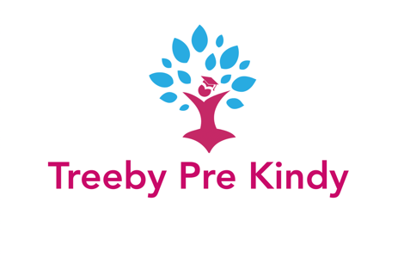
Treeby Pre-Kindy
Parent Information Booklet
Where Little People Explore Imagine & Create

Treeby Pre-Kindy

Provider Number: SE-40024511
Address: Treeby Community and Sports Centre
1 Torwood Ave Treeby WA 6164
Postal Address: 14 Windchime Tce Atwell WA 6164
Phone : 0431 914 143
Email : atwellprekindy@gmail.com
Web : www.atwellprekindy.com.au

We would like to welcome you, and hope that you and your child’s time at our Pre-Kindy will be full of smiles and wonderful happy memories.

Our Pre-Kindy offers an educational program to 2.5 - 4 year olds in an environment that inspires, encourages and enhances children’s imagination. We strongly encourage children’s independence, confidence and self-esteem supporting them and their families with the stepping stones needed for a smooth, happy transition into school.

Staff and Management

Owner/Teacher/Director
Jenelle Turnbull

Educators & Relief Staff
Rochelle Masters
Beyonce Matthews
Melissa Salmon
Dianne Moore

Philosophy of Treeby Pre-Kindy

When a child feels free to explore, imagine and create, their memories will be wondrous!

When a child feels free to explore, imagine and create, their memories will be wondrous!

At Treeby Pre-Kindy we wish for every child who spends time with us to become a happy and confident little person.

When given a secure, safe, supportive and imaginative environment and along with the care and guidance of staff and parents working together, we believe all children can develop the skills they need to learn, and to enjoy life.

We recognise play as an important facilitation of learning. Play for each child is intense, purposeful and serious. We will recognise individual needs through observation and offer the life experiences required to advance through play while providing them with time to learn.
Treeby Pre-Kindy is a reflection of the child’s home where they feel warmth and security. Each child is known as an individual and accepted and programmed for as such.

They feel a respect and ownership of the Pre-Kindy. Their work is displayed at their level and they are encouraged to change the displays. Ideas are discussed and encouraged; this has a bearing on the program. Children work from learning centres using open-ended activities. All resources and materials are accessible, encouraging the children to make problem solving decisions and creative choices to enhance their ideas.

Children need to learn as individuals with a program allowing them, to develop at their own pace, increasing their self-esteem, confidence and knowledge. They are encouraged to join in all the organisation of activities to care for their Pre-Kindy. When using all their senses and “doing”, they can develop their social, emotional, cognitive, physical and creative skills.

Their time with us will be happy, full of fun and lots of smiles … everything that creates wonderful childhood memories!

“Play is in essence untouchable, a private experience, a unique and novel and fascinating part of childhood” Otto Weininger.

Our Program

All experiences and routines provided for the children at our Pre-Kindy are thought out and planned to provide them with experiences to entice imagination and curiosity. Curiosity to learn, explore and find out about the world around them. It is a place where they will enjoy every moment of their new surroundings as they play to learn and learn to play.

Children will be encouraged to learn through their senses using touch, sight, sound, taste and smell. The activities will be varied and designed to spark their interest, with learning areas corresponding to a child’s development levels. Our learning centres are set up so that the children decide what to make or do and we extend on these interests. In our program there is no ‘right way’ for a child to produce a piece of work and they will be encouraged to decide for themselves what the finished piece will look like.

Drama activities will be included within inside and outside areas with role play a major focus as this is where language, social and creative learning through play is best developed. Music is played throughout the day too and we encourage our children to sing and dance as much as they like!

The outside play area is a large learning space where all their Developmental skills are planned for. Each area has a different level of activity where children can choose to engage in quiet play or more active activities. It reflects our ideas with a variety of learning centres that can be extended or modified. The children help with the planning and are encouraged to make changes to their environment.

Relationships are established between educators, children and their families to support growth and confidence. This is enhanced by setting up our Pre-Kindy with opportunities in which they need to develop and become confident and social little learners, giving them a positive start to their schooling life.

General Information
Sessions
Session Times: 8.45am – 2:15pm on Monday, Tuesday
(We only operate during school terms)
Please note that we understand that some of the schools in the areas finishing times makes it hard to pick up your child at these times, you are more than welcome to pick your child up earlier each week if that makes it easier for you.

Fees
Sessions are $65 a day – unfortunately our fees are not covered under CCS.

Enrolment Fee
A $40 non-refundable administration fee is payable on acceptance of a position.

Payment of Fees
Fees are paid by direct deposit payment at the start of each term. Please contact us for the bank details. Payment plans can be arranged if this better suits your needs.

Arrival and Departures
Your child must be signed in and out every day with the time and your signature recorded on the sign in/out sheet provided for each session in the foyer. If your child does not attend a session you must let us know so that we can record the reason for their absence.

Authorised Persons to Drop Off or Collect Your Child
On our enrolment form you are asked to nominate a person/s who is authorised to drop off and/or pick up your child from Treeby Pre Kindy. If there is a change to this please notify us immediately in writing, this can be done by text or email. NOTE: We will not allow any child to leave the Centre unless prior written authority has been obtained from the parent or guardian.

Centre Communication
We publish a newsletter each term which you will receive with our term program by email. We have a notice board and parent information book at the front door which will always have future details listed with regards to information about themes for the term, details about an incursion or outing, and/or general information about the Centre.

Illness or Holidays
In the event of your child not attending due to holidays or illness, your fees will still be charged. Please let us know when your child will absent.

Notice of Withdrawal
If you are planning to leave Treeby Pre-Kindy, we require two weeks (14 days) notice prior to the last day of your child’s attendance. If notice is not given you will be charged the days that your child would have attended in that time.

Holiday Closures
The Centre will be closed on all public holidays and school holidays as per the education department of WA. You will not be charged for these days.

Family Participation
We encourage and invite parents/guardians to be involved with
Treeby Pre-Kindy in several ways:
- Suggestions are always welcome so please talk to one of the team or email it to atwellprekindy@gmail.com
- Join us at one, or all of our incursions or outings throughout the year.
- If you have a hobby or interest that you would like to share and show to the children, then let us know.
- Culture - if you would like to share with us a part of your culture, please let us know.
- We always appreciate any bits and pieces we can use at our woodwork, collage and art areas i.e. untreated timber, paper, small boxes, Christmas and Birthday cards, or any other items you think will help our friends to create masterpieces!
- If it is your child’s birthday, you are welcome to bring in a cake (preferably cupcakes) or biscuits so that we can celebrate with them.

Incursions and Outings
Incursions... We encourage parents/guardians and community members to visit Pre Kindy to help us run an incursion that links to a theme in our program e.g. a Fireman visiting as part of our Emergency Services theme.
Outings... As we are very lucky to be connected to the local primary school, we may visit them during the year. We will also conduct regular outings to the adjacent oval. Prior to doing these outings, authorisation will be required from you. A Risk minimisation plan is available to view at the service. These outings will support the children’s learning and transitions to ‘big school’.

Fire and Emergency Drills
In the event of an emergency that requires evacuation, children are moved into a single group. All play and toilet areas are checked, children counted, and with all staff members are moved through the doors to the oval. Emergency services and parents will be notified. If you are in the building at the time of either an emergency or drill, our priority is the safety of the children, however you must evacuate the building according to our procedure with the children and staff.

Health and Wellbeing
Parents/guardians are asked to keep infectious children at home. We cannot admit any child who appears to be suffering from a communicable disease or condition that may affect the health of other children and staff members.
Please take note of the following points:
• Parents/guardians will be contacted and asked to collect their child immediately if the child presents with a temperature of 38 degrees of higher.
• Parents/guardians are responsible for collecting/arranging for collection of an ill child promptly. Every effort will be made to contact the parent/guardian or emergency contact person. The Director has the prerogative to call an ambulance in the case of an emergency, and the cost will be borne by the parents.
• Parents/guardians will be notified about the occurrence of any infectious disease (with the exception of those disease dealt with by the Commonwealth Privacy Act and the State Health Act) in either the staff or children. Pre Kindy is not responsible for any illness contracted at the Centre.
• If first aid is required it will be administered by a staff member who holds a recognised Senior First Aid Certificate.
• For minor accidents, the parent or person authorised to collect the child will be notified when the child is picked up and asked to sign our accident report book.

Medications
All medications must be handed to a member of staff and parents must fill in our Medical Authority form for times and amounts of medication to be administered. Your child’s name must be printed on the label of the medication. Authority cannot be given for medications or treatments (i.e. eye drops, ointments, etc) which have been prescribed to another person.

Non-discrimination
The Pre Kindy team implements the Federal Governments guidelines on cross cultural, non-gender bias and also accords with the Disability Discrimination Act.

Media Permission
Your child may be photographed/videoed for:
• use in programming and pictorial displays within the Centre
• publication in the Pre Kindy newsletter, social media and website
• media publications such as community newspapers.
If you do not wish for images of your child to be taken, displayed or publicised, you need to inform us in writing.

Need to chat?
If you have any questions or concerns about
• your child’s day at Pre Kindy
• our programs
• your account
• transition from Pre Kindy to school
Please let one of the staff know and we will be more than happy to organise a time to talk with you

Other Notes
Information provided in your future enrolment form are used for Pre Kindy programming and are kept strictly confidential. A parent/guardian may view all written observations relating to their child.
Confidential information is never revealed to people/organisations outside the Pre Kindy team without parent/guardian permission, in writing or legal documentation instructing otherwise.

Your Child’s Day

Play to Learn and Learn To Play
At Treeby Pre Kindy we embrace the concept of play based learning which is the basis for the Early Years Learning Framework (EYLF), and with the release of the Australian Curriculum in 2011 we now see Kindy classrooms taking on the same ideology that Treeby Pre-Kindy staff have been working with for years. Our learning and play programs are guided by the outcomes within the EYLF, and are developed to assist with each child’s development no matter their age and observations and evaluations are done accordingly.

Early Years Learning Framework
Treeby Pre-Kindy’s programming supports the Early Years Learning Framework (EYLF). The Framework recognises that early childhood is a vital period in children’s learning and development. EYLF embodies the idea of ‘belonging, being and becoming’. Belonging is all about children’s relationships with the people and communities around them.
Being simply means allowing children to be children.
Becoming focuses on children’s growth and development in these
early years.
All children at the Centre will be observed by Pre Kindy staff for programming and/or training purposes.

Toilet Training
Children all develop at different stages and we are aware that some children are not quite ready to be toilet trained when they attend our service. Children are more than welcome to attend and do not need to be toilet trained, you are just required to supply nappies/pull ups for your child. When your child is ready to begin using the toilet, we will work with you and your child to achieve this goal. If you have nay questions about toilet training or would like some help, we are more than happy to assist you.

Your Child’s First Day
It is very natural for parents to feel a little anxious on your child’s first day.
You are always very welcome to phone any time and check that your
child has settled in and is happy.

What to bring to each session ...
• A piece of fruit/healthy snack in labelled container for snack time.
• A bag and water bottle with name clearly marked.
• Lunchbox with name clearly marked.
• A change of clothes that need to be marked with their name – please also ensure any clothes worn during the day are also named.
• A hat for outside play.
• Please remember to apply sunscreen to your child before you drop them off. Sunscreen will be re-applied by staff throughout the day.

Meal Times
If your child has special needs concerning food for health, cultural or religious reasons please notify us.
Families need to provide fruit for morning tea and lunch for their children.
Some suggestions for lunch are - wholemeal breads, salad bits, fruit, yoghurt, eggs, cold meats, dried fruit, muesli and cheese. We always encourage children to eat the “healthy” items in their lunches before any treats. We also encourage families to fill drink bottles with water, rather than flavoured drinks. Lunch boxes and containers need to have your child’s name marked on them.

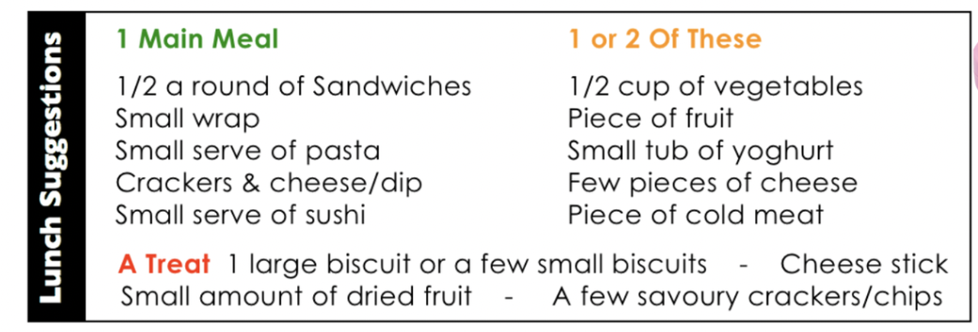

Hygiene
Staff encourage the children to follow the simple rules of hygiene by prompting children’s hand washing; care when eating and drinking; assisting them to wipe their own nose, and other basic rules of general cleanliness.

Behaviour
We aim to foster sociably acceptable behaviour by using a positive approach and encourage sharing and shared play amongst the children.
Children are made aware of the basic rules that ensure the happiness and well-being of all the children at Pre Kindy.

Quality Improvement Plan
This is an important part of the standards and it is a requirement for services to develop ongoing Quality Improvement Plans (QIP). The aim of the QIP is to help providers self-assess their performance in delivering quality education and care and to plan future improvements. The QIP also helps the regulatory authorities with their assessment of the service. A QIP helps providers to document the strengths or their service and to recognise areas for improvement.
We have a comprehensive QIP in place to support us to meet the requirements of the National Quality Standards. If you wish to view our QIP or find out more about our Quality Improvement Plan please ask us and we will be happy to assist you.

National Quality Framework
Atwell Pre Kindy is registered with the National Quality Framework. To find out more about the NQF and how it affects you and your child, visit the Australian Children’s Education and Care Quality Authority ACECQA at www.acecqa.gov.au/families.
Education and Care Regulatory Unit
Level 7, 130 Stirling Street
PERTH WA 6000
Phone : (08) 6277 3889

Our team looks forward to
welcoming you and your family to
Treeby Pre-Kindy.

Kind Regards
Jenelle Turnbull
Owner/Director

